Project Development Phase
Integration
Date | 12 July 2026
Team ID | SWTID-2026-4644
Project Name | Smart Lender
Phase | 5. Project Development Phase

Purpose
Integration covers how the independently developed pieces — the ML pipeline (Data Collection through Model Selection), the backend (Flask routes and encoding logic), and the frontend (HTML/CSS/JS templates) — were connected into one working application, and how that connection was verified.

Integration Points
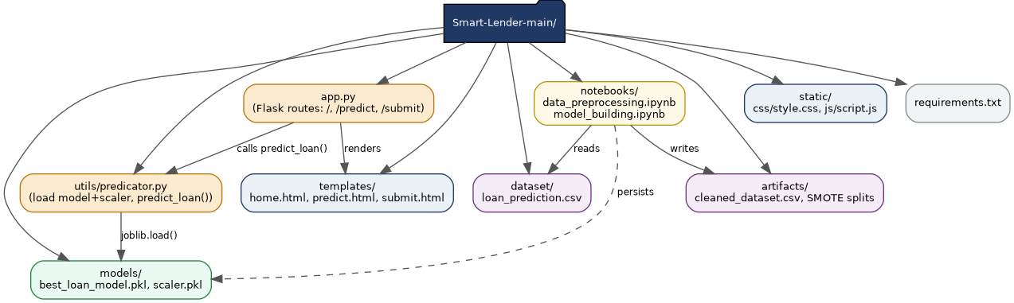
Figure 1: Codebase structure showing how modules integrate (also shown in the Project Design Phase's diagrams).
Integration Point | Connects | Mechanism
ML pipeline → Backend | notebooks/model_building.ipynb output → utils/predicator.py | Persisted files (models/best_loan_model.pkl, models/scaler.pkl) loaded via joblib.load() at Flask startup
Backend → Frontend (request) | app.py → templates/predict.html | Flask's render_template() renders the form; form POSTs back to /submit
Backend → Prediction Service | app.py's /submit route → utils/predicator.py | Direct Python function call: predict_loan(features)
Backend → Frontend (response) | app.py → templates/submit.html | render_template() passes the prediction and echoed form values into the result page

Integration Testing Performed
Rather than testing each module in isolation, the integration was verified by exercising the full, live, end-to-end flow: starting the real Flask server, loading the real persisted model/scaler, and sending real HTTP requests that traverse every integration point listed above. This is documented in detail in the Project Testing phase, including the exact request payloads and observed results for both the Approved and Rejected business scenarios.

Integration Risks Identified
- Encoding drift risk: the categorical encoding scheme is duplicated in two places (the training notebook and app.py) rather than shared from a single source of truth. If one is changed without the other, predictions would silently become incorrect rather than erroring — a maintainability risk worth addressing by extracting a shared encoding module.
- No integration-level input validation: as documented in Backend_Development.docx and Frontend_Development.docx, invalid input is not caught at any integration boundary before it reaches predict_loan(), causing the unhandled HTTP 500 defect.

Successful Integration Evidence
Despite the risks noted above, the integration was confirmed fully functional for well-formed input: both supplied business scenarios (low-risk → Approved, high-risk → Rejected) passed end-to-end through every integration point, confirming the ML pipeline, backend, and frontend are correctly wired together for the application's primary use case.

